**RESTAURANT STOCK & CART MANAGEMENT**

**MINI PROJECT REPORT**

Department of Master of Computer Applications

By

**RAMASAMY J**

**C19102PCA6048**

Under the Guidance of

**DR.R. VELMURUGAN**

**ABSTRACT**

TasteYum stock & cart management is a web-based application developed using Jsp, Java, servlet, CSS, JavaScript, and MySQL to register data. The proposed project for tasteyum Stock & Cart management is developed to provide the item stock details to the users. The is beneficial to both the admins and users. Using the online web application, the admin can do managing activities such as add new cart items, new services, edit and delete the offers and update or modify the existing price plans. It helps the users in submitting the service request and queries.

This Taste Yum Stock Cart Management web-based application can be used by the food delivery industry. This system will allow hotels and restaurants to increase scope of business by reducing the labor cost involved. The system also allows to quickly and easily manage an online stock and cart menu which customers can browse. Restaurant employees then use these orders through an easy to navigate graphical interface for efficient processing.

**1. SYSTEM REQUIREMENTS**

* 1. **Hardware Requirements**

|  |  |
| --- | --- |
| Processor | Intel Dual Processor 2.6 GHz |
| RAM | 4 GB RAM |
| Hard Disk | 500 GB |

* 1. **Software Requirements**

|  |  |
| --- | --- |
| Operating System | Windows 10 |
| IDE | Eclipse Neon 3.0 |
| Data Base | SQL Server |
| Front End | HTML, CSS, JSP, JS |
| Back End | JAVA, Servlet, JDBC |

1. **PROJECT DESCRIPTION**

This project describes the Automobile spare parts &Management facilitates user to book for service. This System provides submission of all services as well as all kinds of parts are possible. This System will provide facility for user to book anytime from anywhere. This System keeps the history of the past.

The website is fully focused on viewing the stock items & price before purchasing in real for user and managing of item, helping customer with details.

So, we have developed a website by providing item details and user-friendly platform for users/customers.

Store Admins to regulate the stock in real.

1. **DATA FLOW DIAGRAMS**
   1. **Use Case Diagram**



* 1. **Data Flow Diagram**

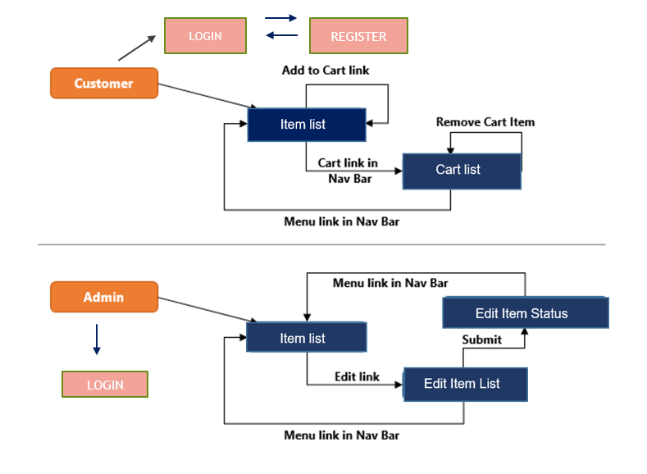

1. **TABLE DESIGN**
   1. **User Table**

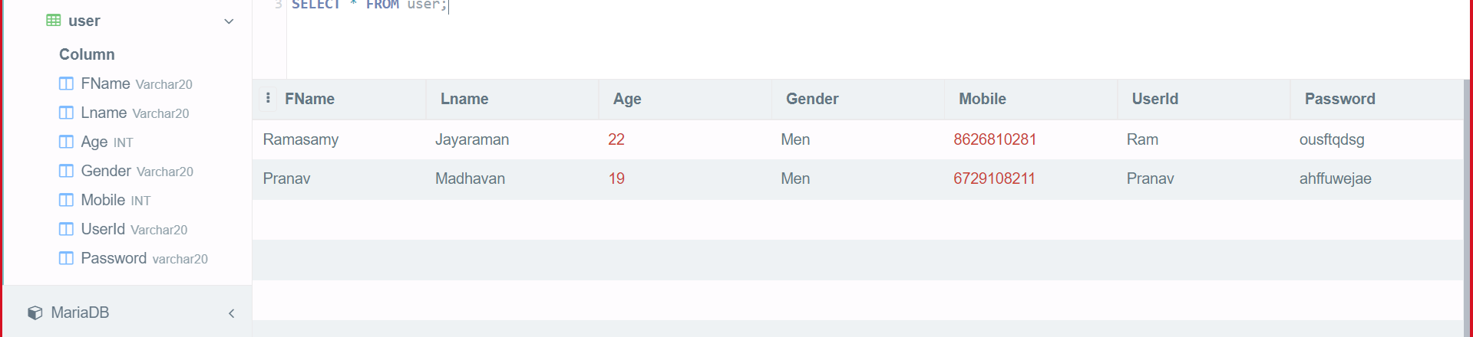

* 1. **Menu Item List**

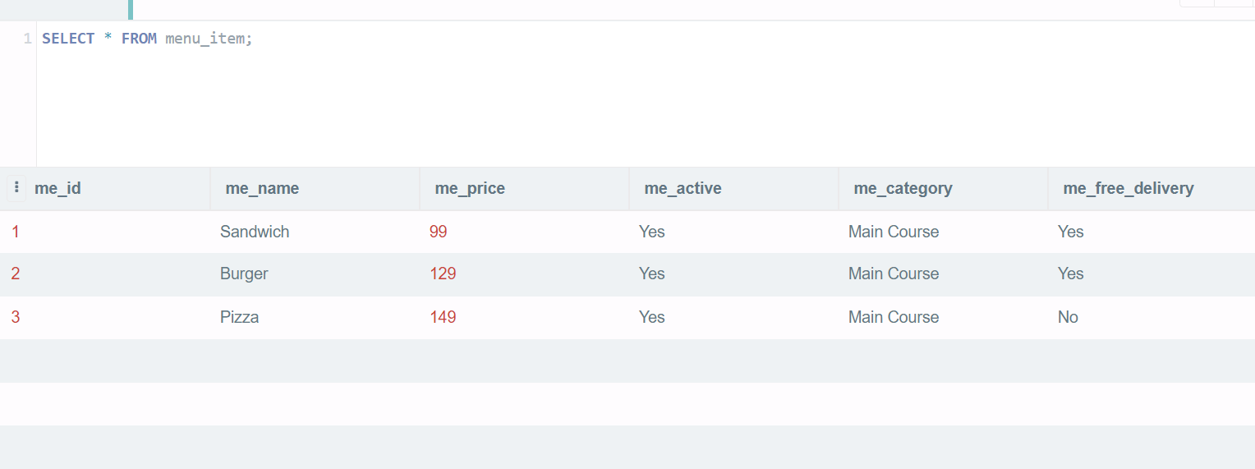

* 1. **Admin Table**

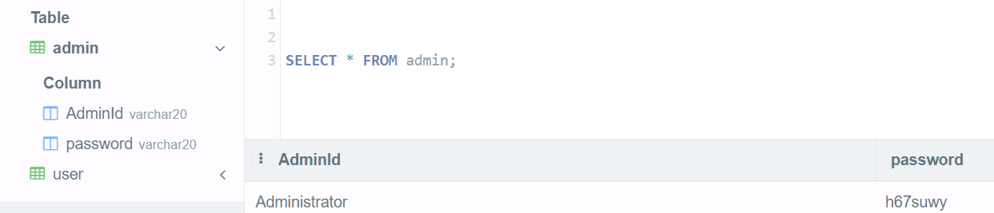

* 1. **Cart Item Table**

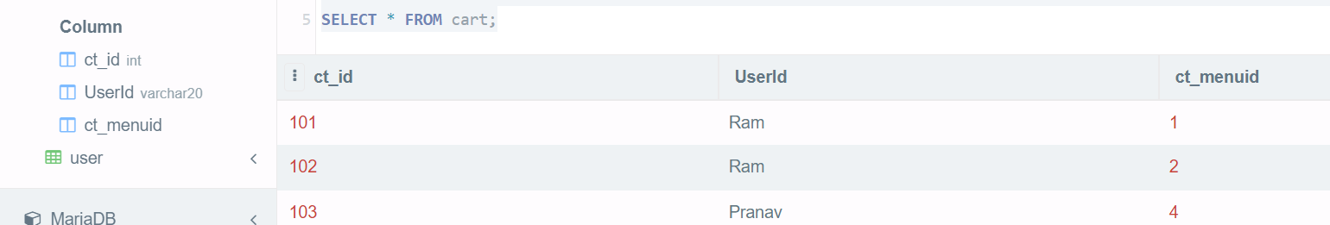

1. **FORMS AND REPORTS**
   1. Login Page - User

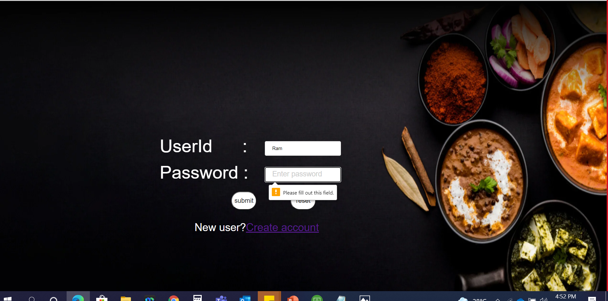

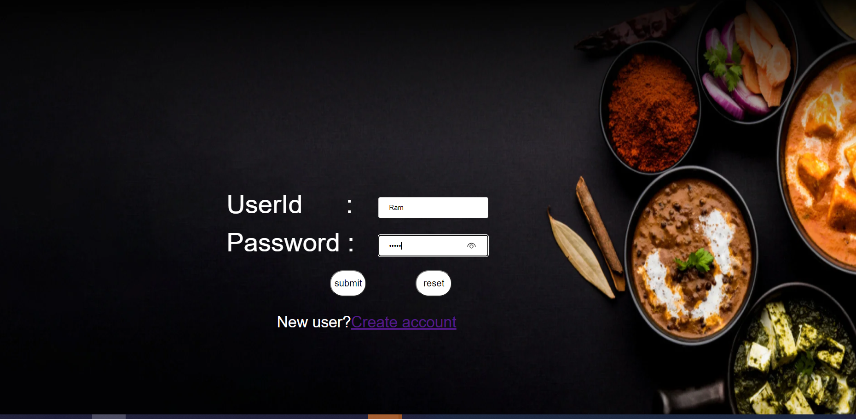

* 1. Registration Page

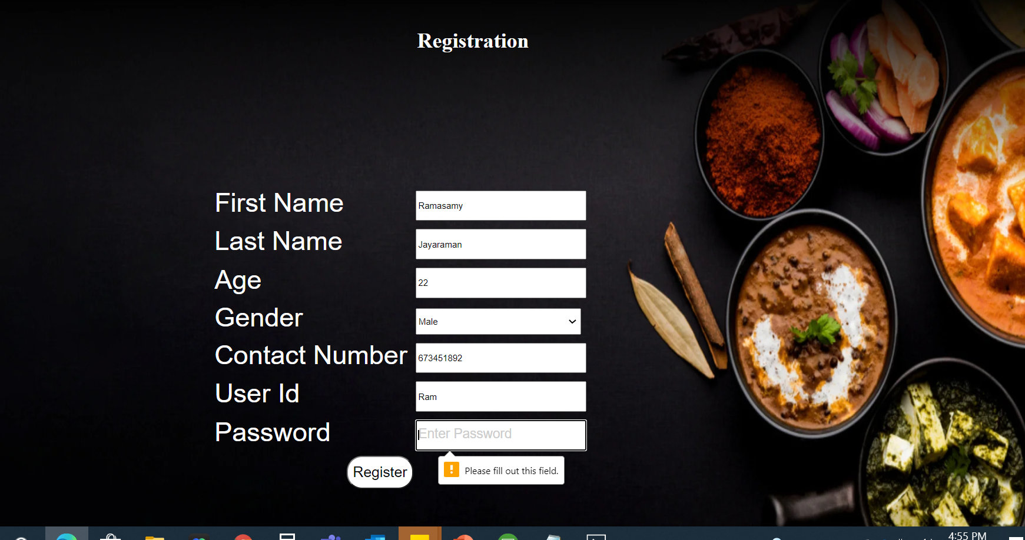

* 1. Home Page - Customer

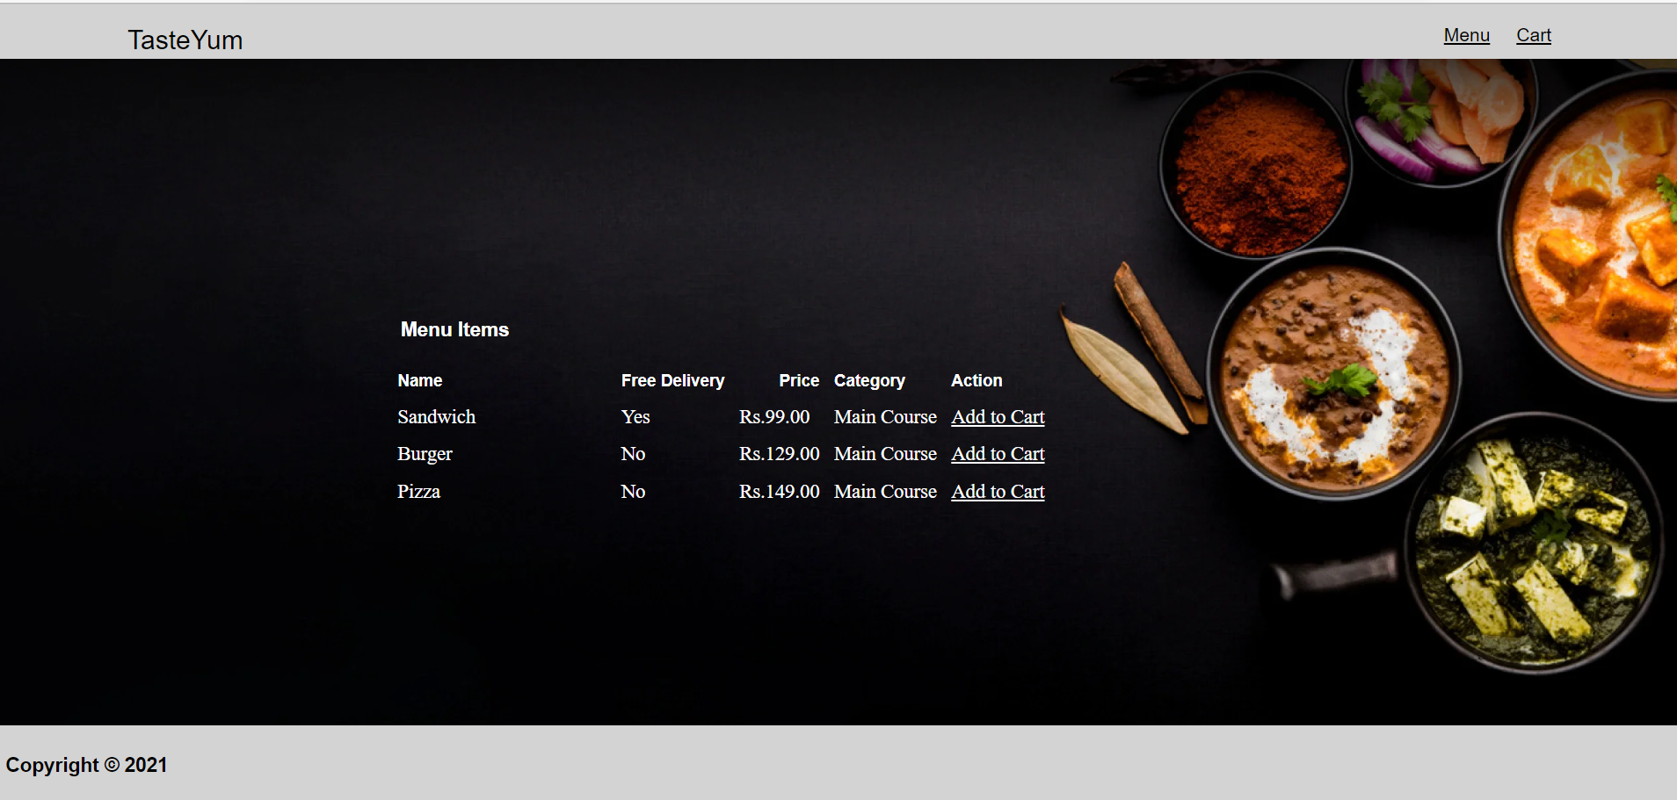

* 1. Add to Cart

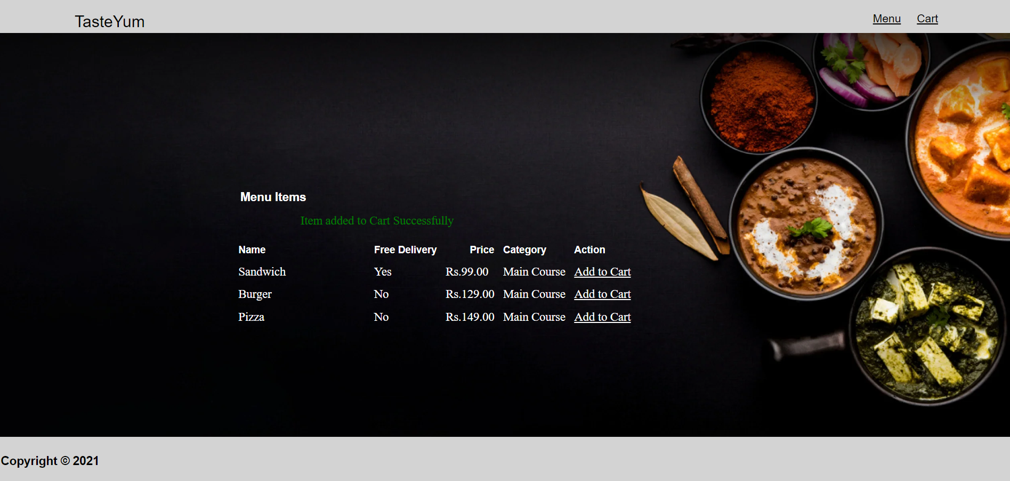

* 1. Cart page

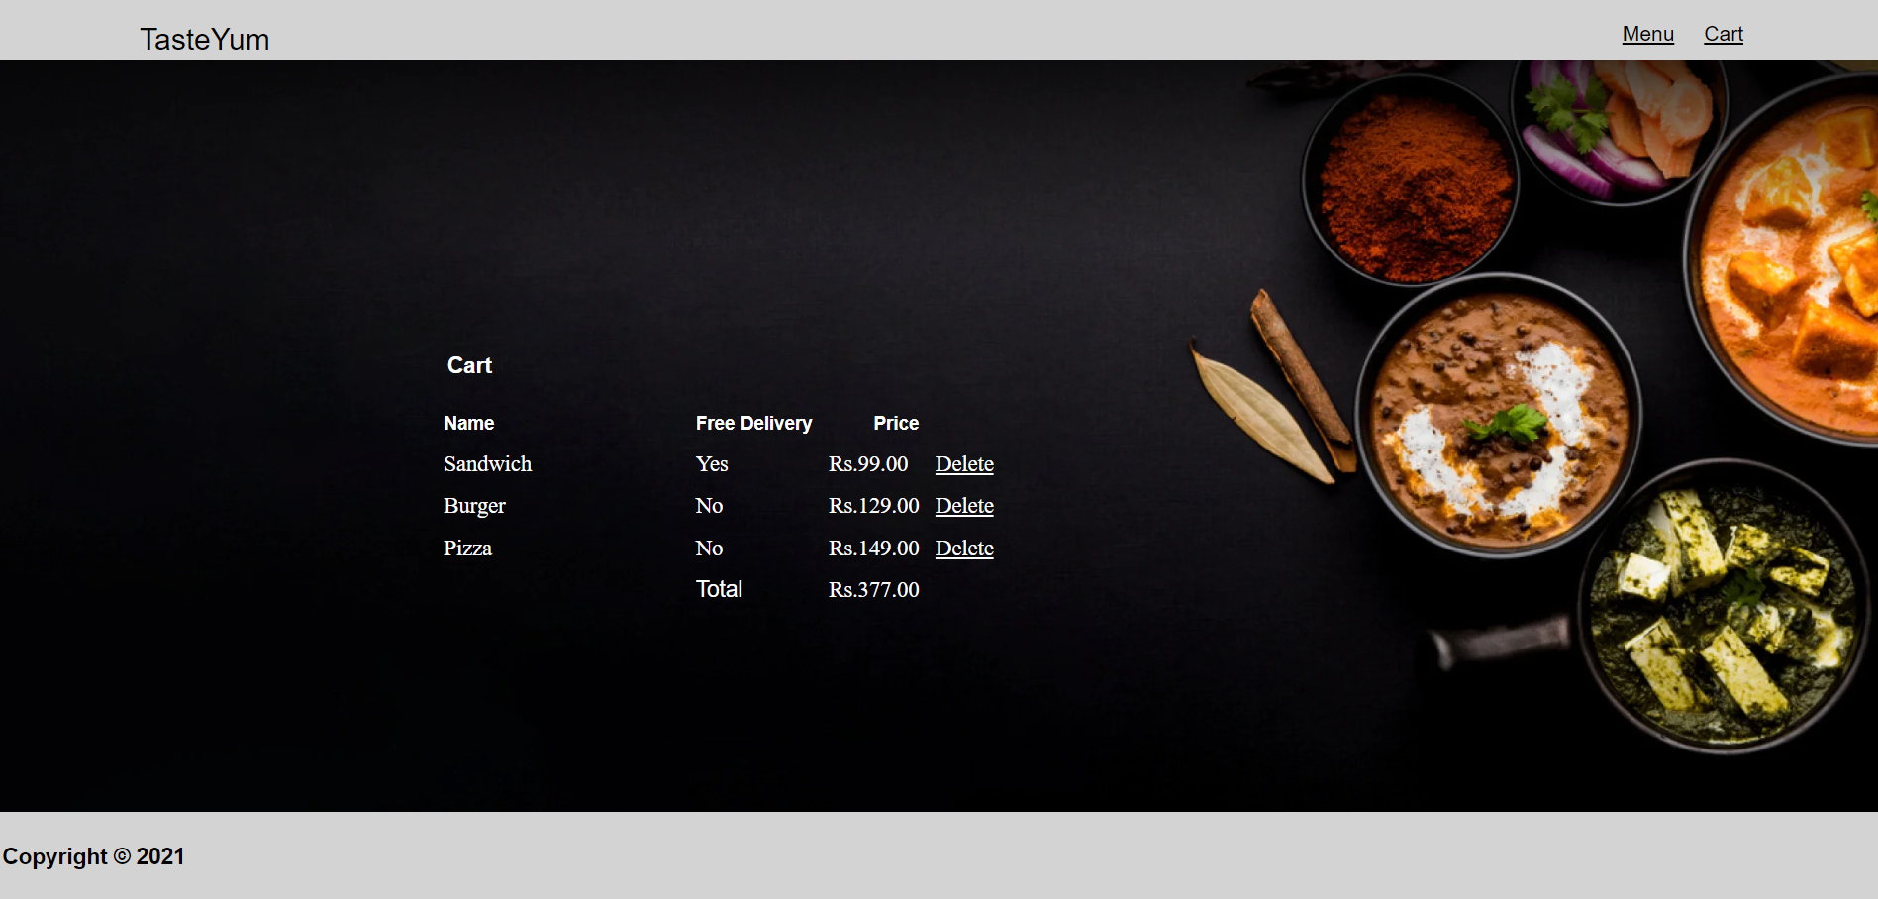

* 1. Remove Cart

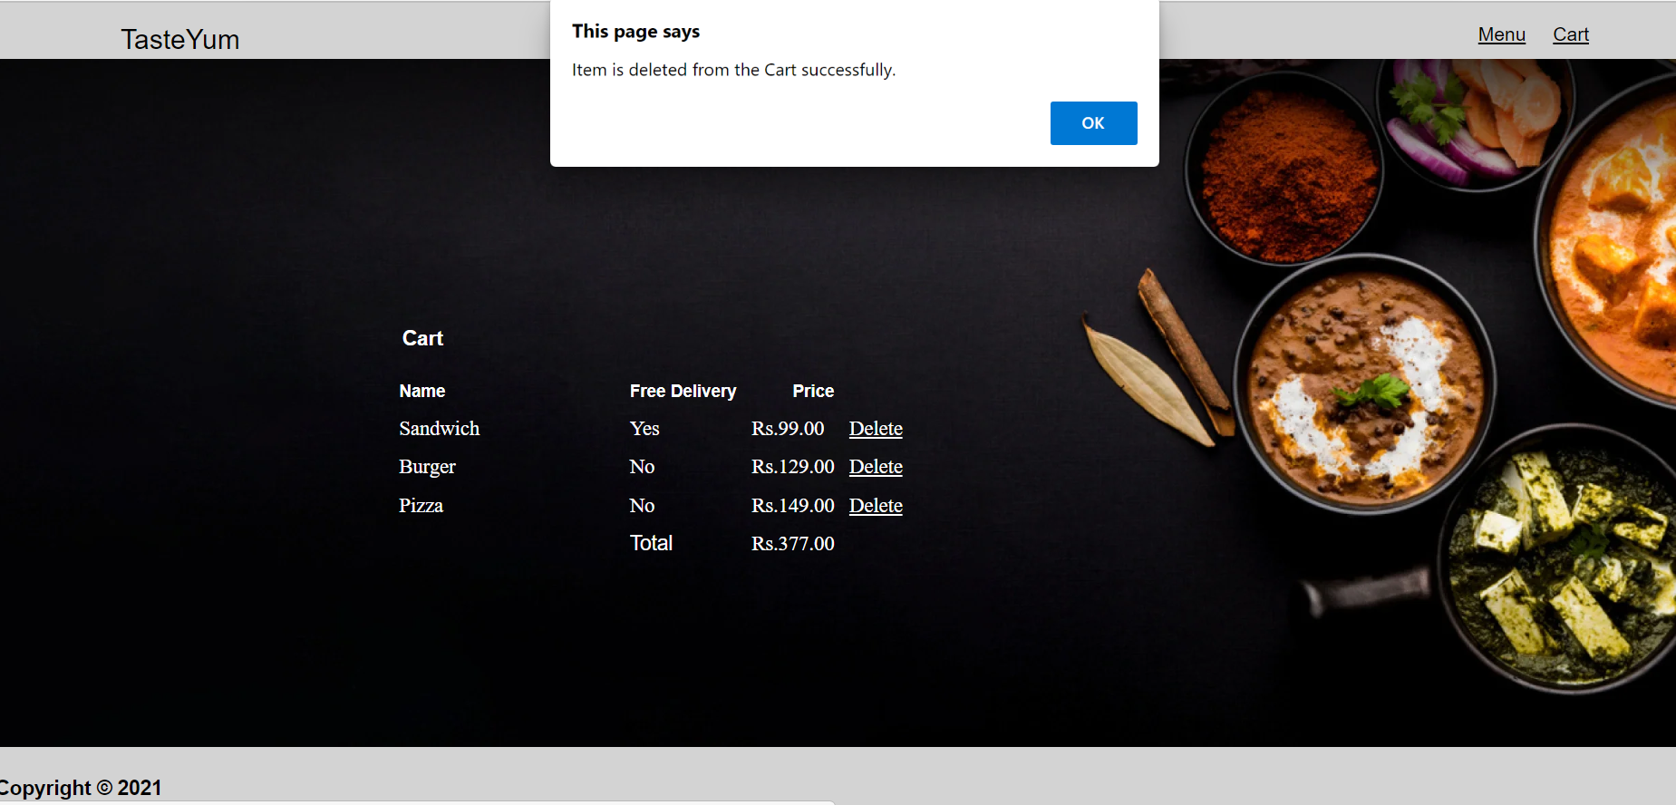

* 1. No Items – Cart

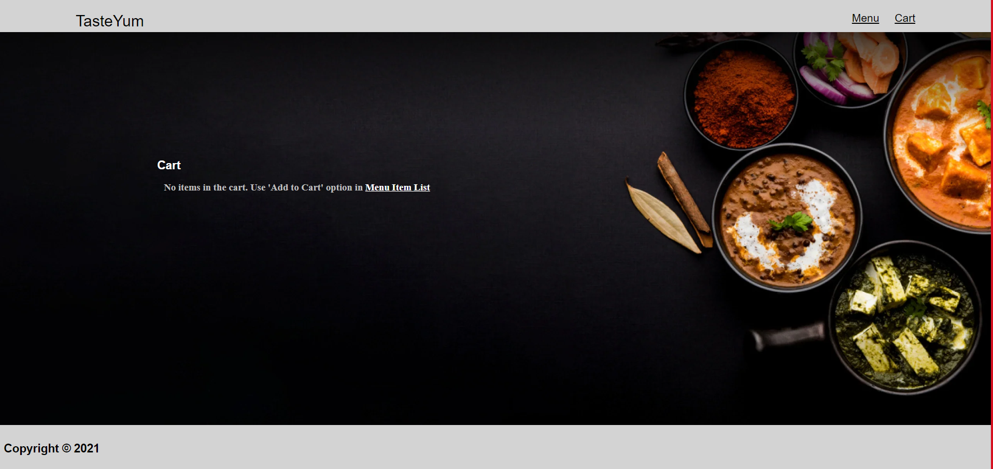

* 1. Home Page - Admin

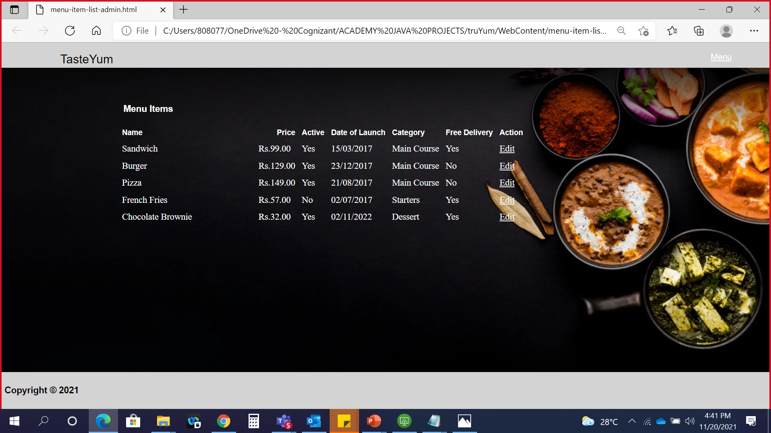

* 1. Edit Page – Admin



* 1. Validations

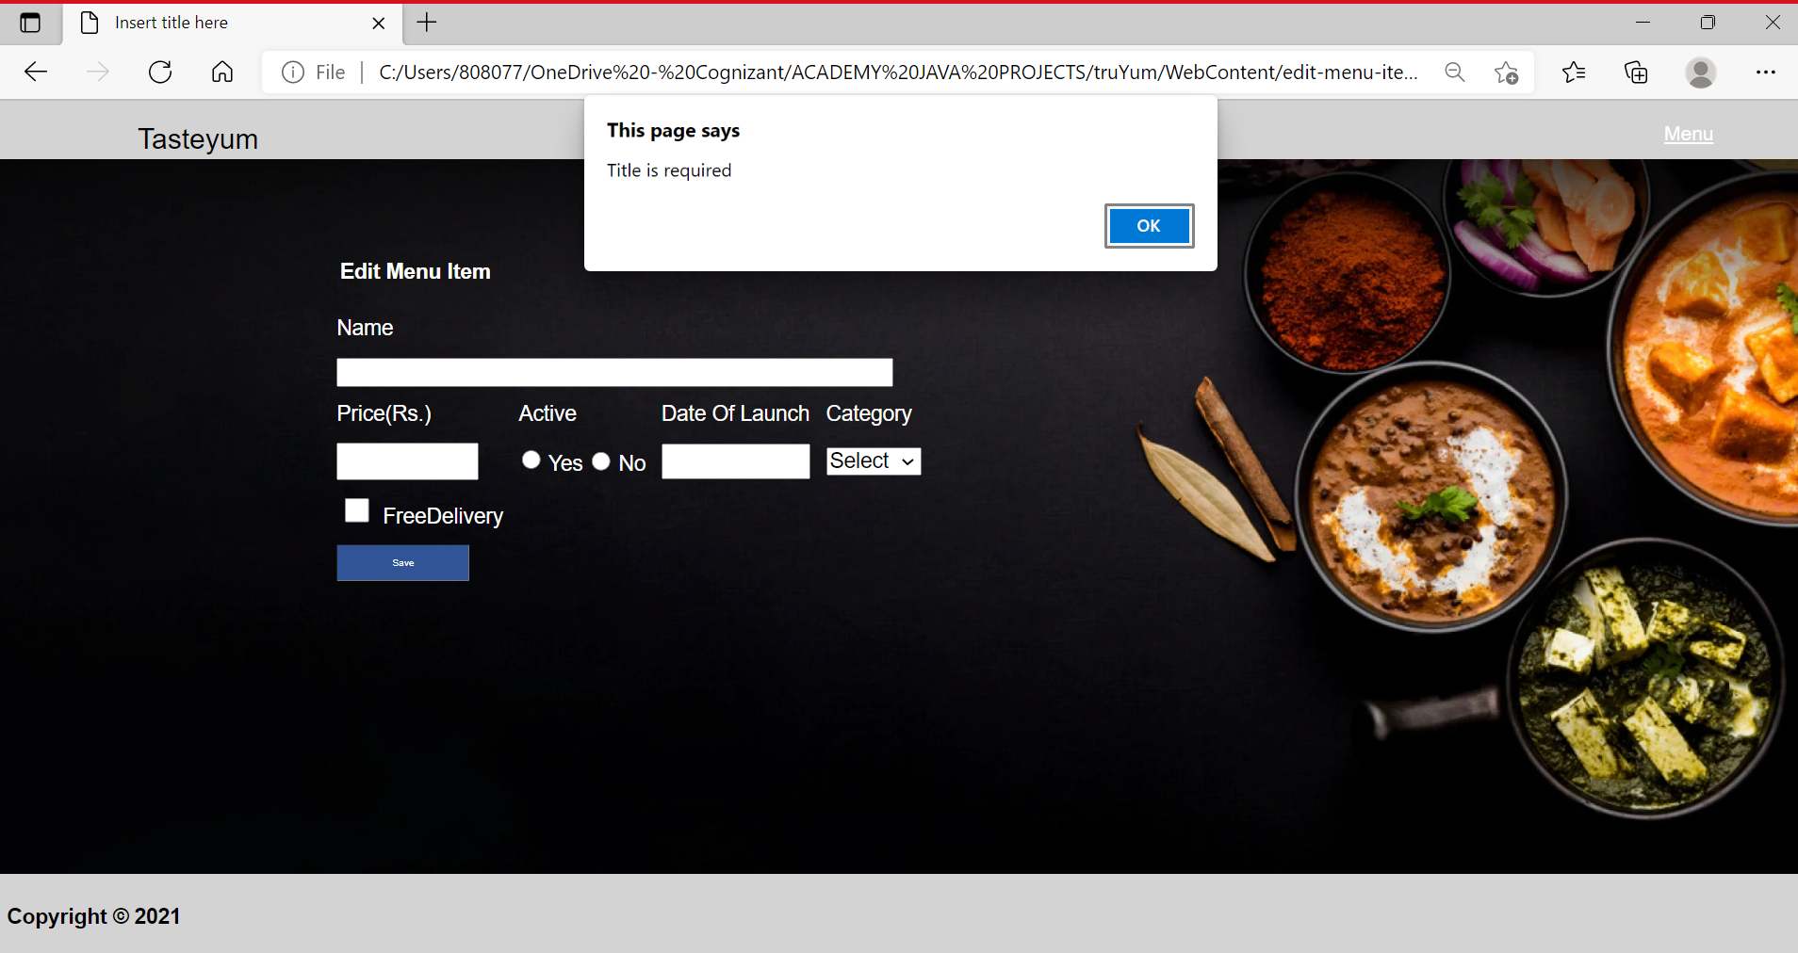

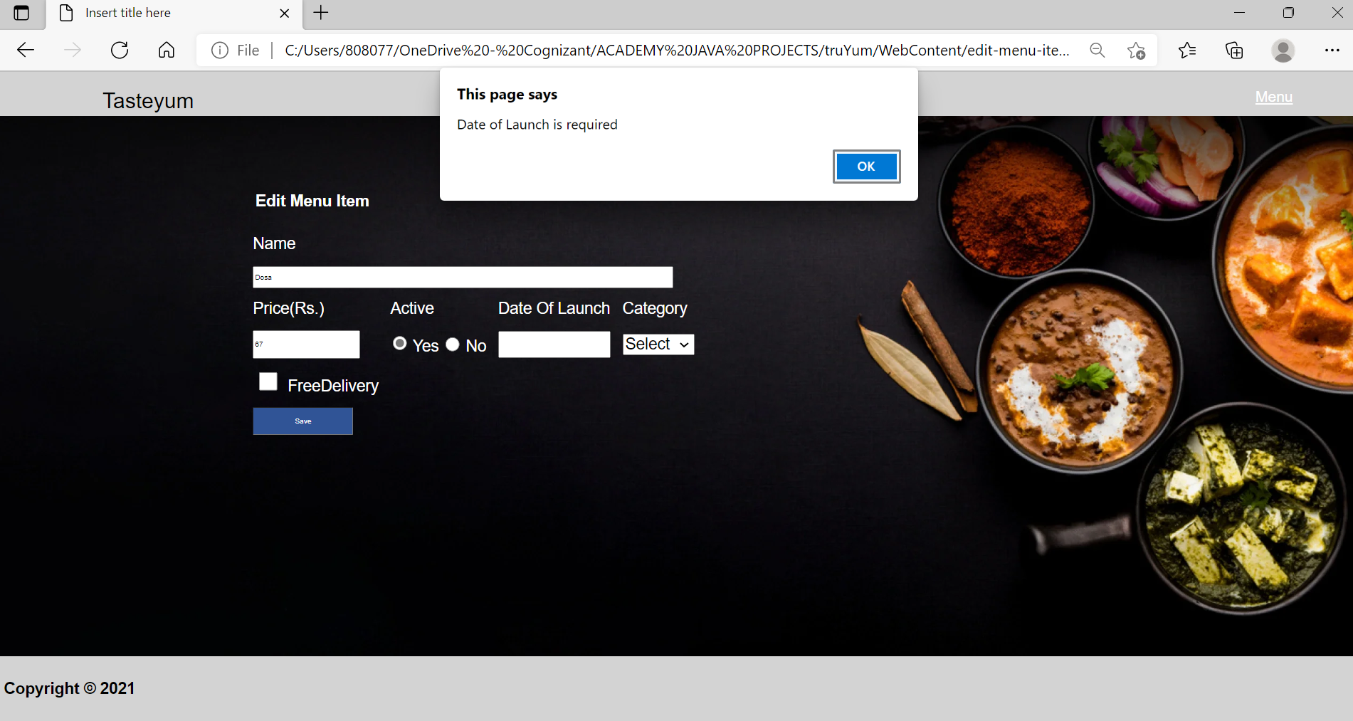

* 1. Item Edit Success Page – Admin

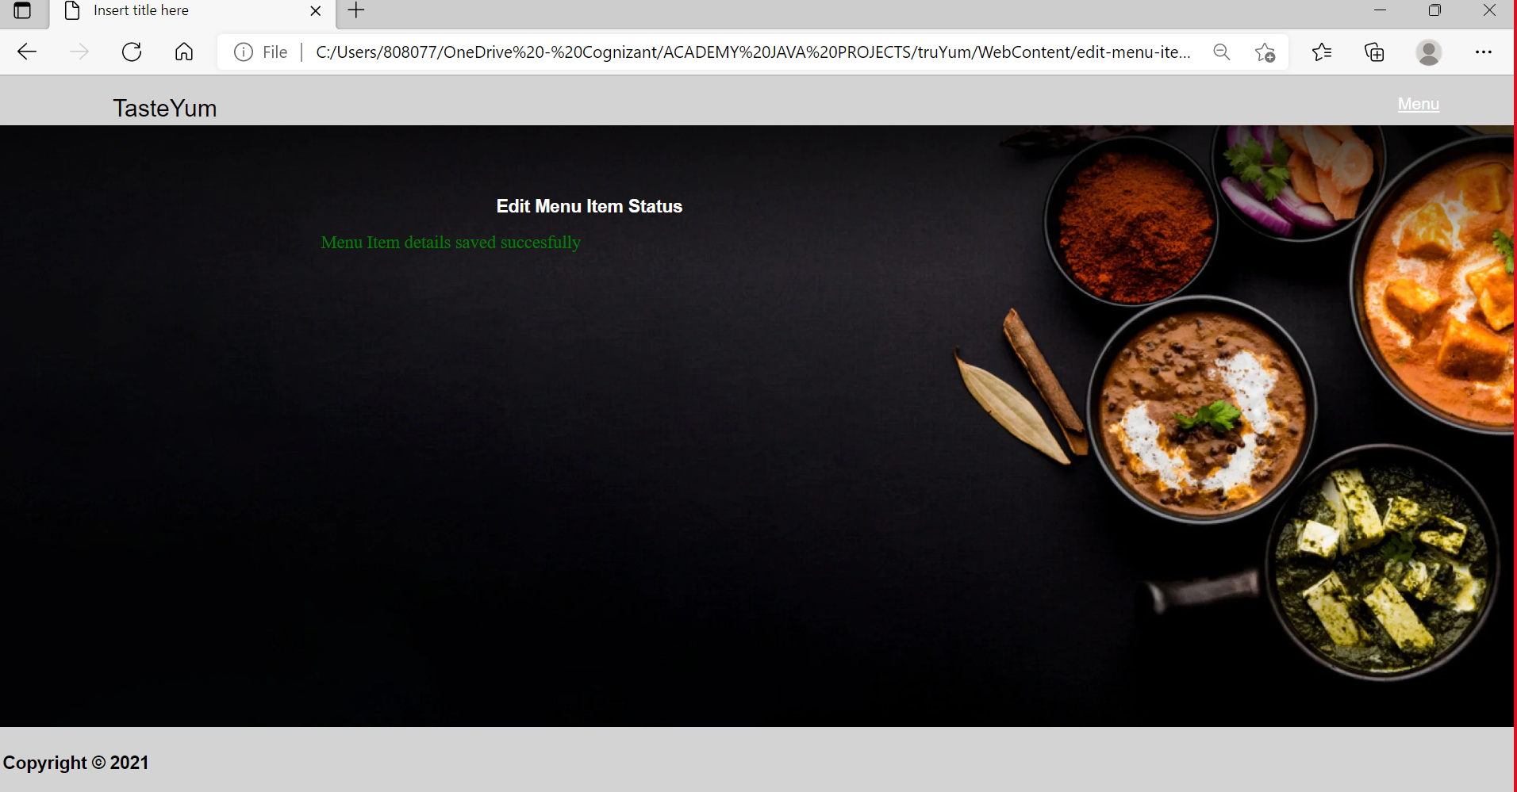

1. CONCLUSION AND FUTURE ENHANCEMENTS
   1. Conclusion

It is concluded that the application works well and satisfy the end users. The application is tested very well, and errors are properly debugged. The application is simultaneously accessed from more than one system. Simultaneous login from more than one place is tested.

The main aim of developing TasteYum Stock & Cart Management system is to provide user a friendly and easy way to handle inventory in our website.

Future enhancements can be made to the application. So that the web application functions are very attractive and useful manner than the present one.

* 1. Future Enhancements

In the future development, we can enable the facility to let the customer/user to review & order the available stock. In the admin side, we can enhance the service by adding the query / FAQ sections to make the website even more efficient to use.